NORTHWIND SALES PERFORMANCE DASHBOARD
Using Microsoft Power BI
Project Report
Submitted By | Name: [Your Name]
Tool Used | Microsoft Power BI Desktop
Source File | NORTHWIN_DATA_COMPLETE.pbix
Dataset | Northwind Traders sample database

1. Introduction
For this project, I built a sales performance dashboard in Power BI using the Northwind Traders dataset. I picked this dataset because it goes beyond a single flat table — it links customers, orders, order line items, products, categories, employees, and shippers together, so it gave me a chance to work with a proper relational data model instead of one wide spreadsheet.
The goal behind the dashboard was the same as with any management dashboard: take a set of relational tables that nobody wants to read row by row and turn them into something a sales manager could open and understand in a minute. Once built, the dashboard lets a user filter by year, country/region, and product category, and every visual on the page updates together.

2. Objectives
Going in, I set out with a few clear goals for what I wanted the dashboard to do:
- Analyse Northwind's order and sales data across customers, products, and employees.
- Build something interactive rather than a static report.
- Track how order volume and sales moved over time.
- Compare performance by product category, by country, and by sales employee.
- Give a way to drill into a single product category for a closer look.

3. Dataset Description
The Northwind dataset is a relational sample database made up of several linked tables. The tables I actually worked with were:
Table | What it holds
customers | Customer records, including company name and country
orders | One row per order, including order date and the customer/employee who handled it
order_details | Line items for each order — product, quantity, unit price, and discount
products | Product catalogue, including product name and its category
categories | Product category names (also hosts the report's core measures)
employees | Sales employee records, including employee name
shippers | Shipping companies used to fulfil orders

These tables are connected through a standard star-like model — orders links out to customers, employees and shippers, while order_details links orders to products, and products links to categories — which is what lets a single slicer selection (say, a country or a category) filter every visual on the page at once.

4. Data Preparation
Before building any visuals, I worked through the model to make sure the tables were properly connected and ready to report on:
- Imported the Northwind tables (customers, orders, order_details, products, categories, employees, shippers) into Power BI Desktop.
- Checked that Order Date was recognized as a proper date field so the built-in Date Hierarchy (Year / Quarter / Month) would work.
- Verified the relationships between orders, order_details, products, customers, and employees in the model view.
- Set up the DAX measures needed to drive the KPI cards and charts.

5. DAX Measures Used
I created six core measures to power the KPI cards and visuals across the report:
Measure | Purpose
TOTAL SALES | Overall sales value across all orders
TOTAL ORDER | Count of orders placed
TOTAL QUANTITY SOLD | Total units sold across all order lines
TOTAL FREIGHT | Total freight/shipping cost across orders
AVERAGE FREIGHT | Average freight cost per order
NUMBER OF CUSTOMERS | Distinct count of customers

These measures are simple SUM, COUNT, and DISTINCTCOUNT aggregations, but together they drive every KPI card and chart in the report.

6. Dashboard Components
The finished report is spread across five pages, described below.
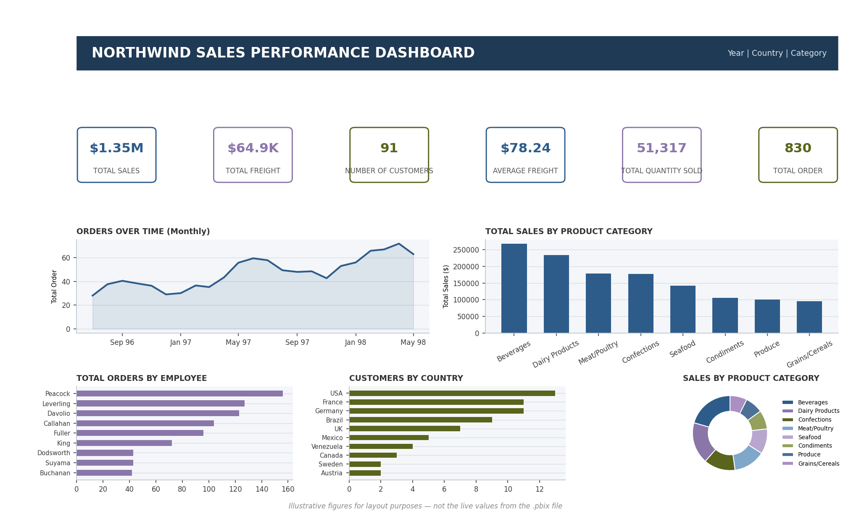
Figure 1. Northwind Sales Performance Dashboard — full overview mockup (KPI cards, trend, category, employee, country, and category-share visuals).

KPI Cards
A row of KPI cards shows Total Sales, Total Freight, Number of Customers, Average Freight, Total Quantity Sold, and Total Order at a glance — the same role the KPI row plays in the Walmart dashboard, giving a one-second read on overall performance before digging into any single chart.

Orders Over Time
A line chart tracks Total Order by Order Date, broken down to the month level using Power BI's built-in date hierarchy. This is the equivalent of the Weekly Sales Trend chart in the Walmart report — it shows whether order volume is growing, flat, or seasonal across the period covered by the data.
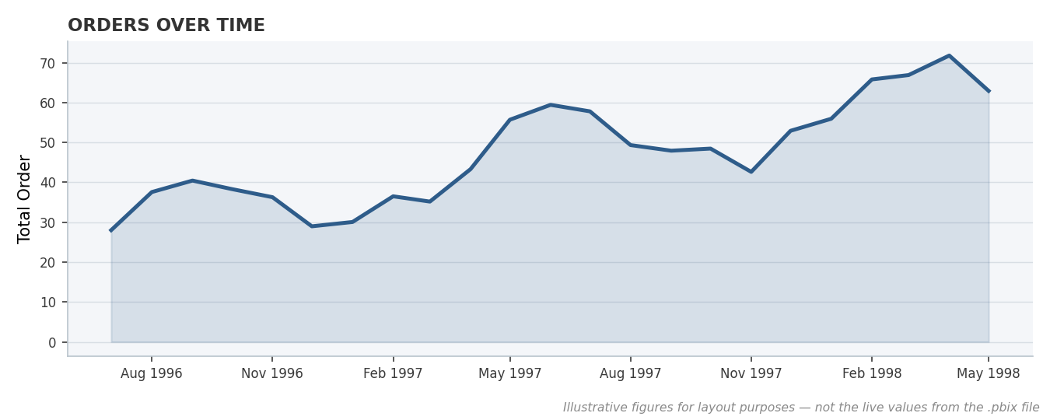
Figure 2. Orders Over Time — monthly Total Order trend.

Total Sales by Product Category
A clustered column chart breaks Total Sales down by Category Name, making it easy to see which product categories (Beverages, Dairy Products, Confections, and so on) are driving the most revenue.
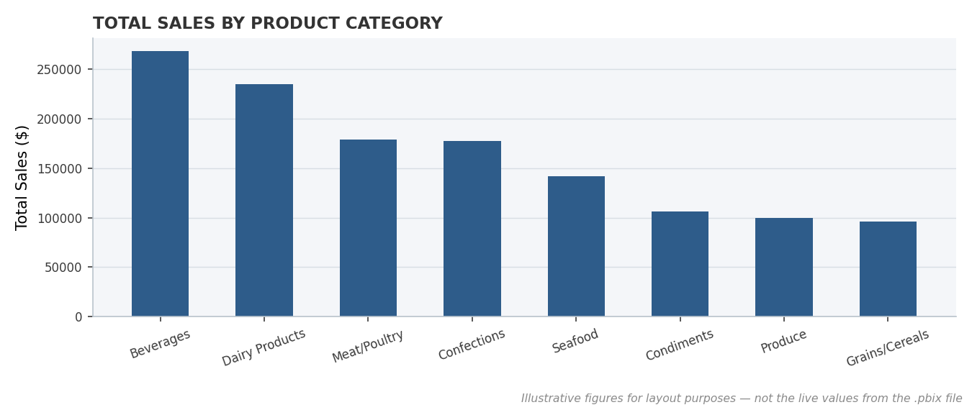
Figure 3. Total Sales by Product Category.

Total Orders by Employee
A clustered bar chart lines up Total Order by Employee Name, similar in spirit to the Sales by Store chart in the Walmart report — it's useful for spotting which sales employees are handling the most orders.
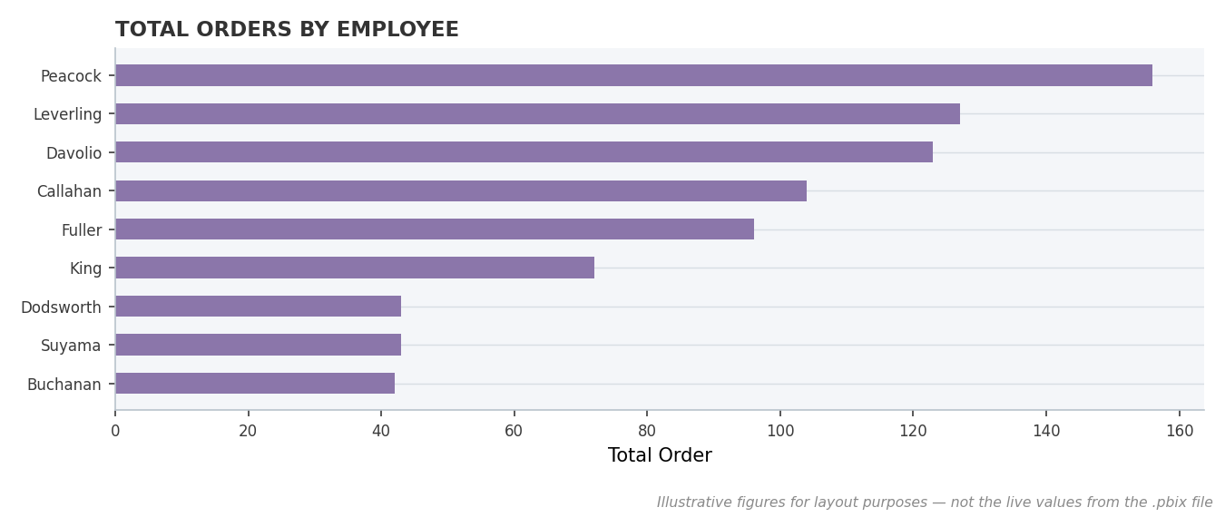
Figure 4. Total Orders by Employee.

Customers by Country
A second clustered bar chart shows Number of Customers by Country, giving a quick read on where Northwind's customer base is concentrated geographically.
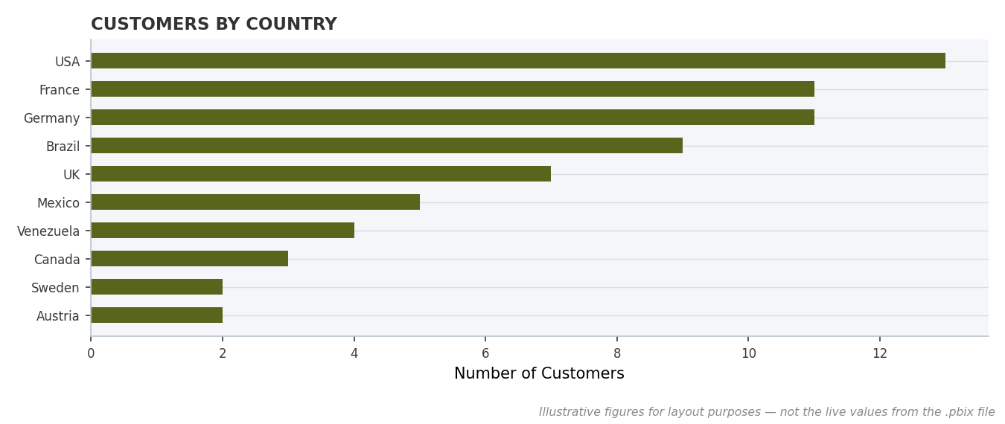
Figure 5. Customers by Country.

Sales by Product Category (Donut)
A donut chart splits Total Sales by Product Category, playing the same proportion-at-a-glance role that the Holiday vs Non-Holiday pie chart plays in the Walmart report.
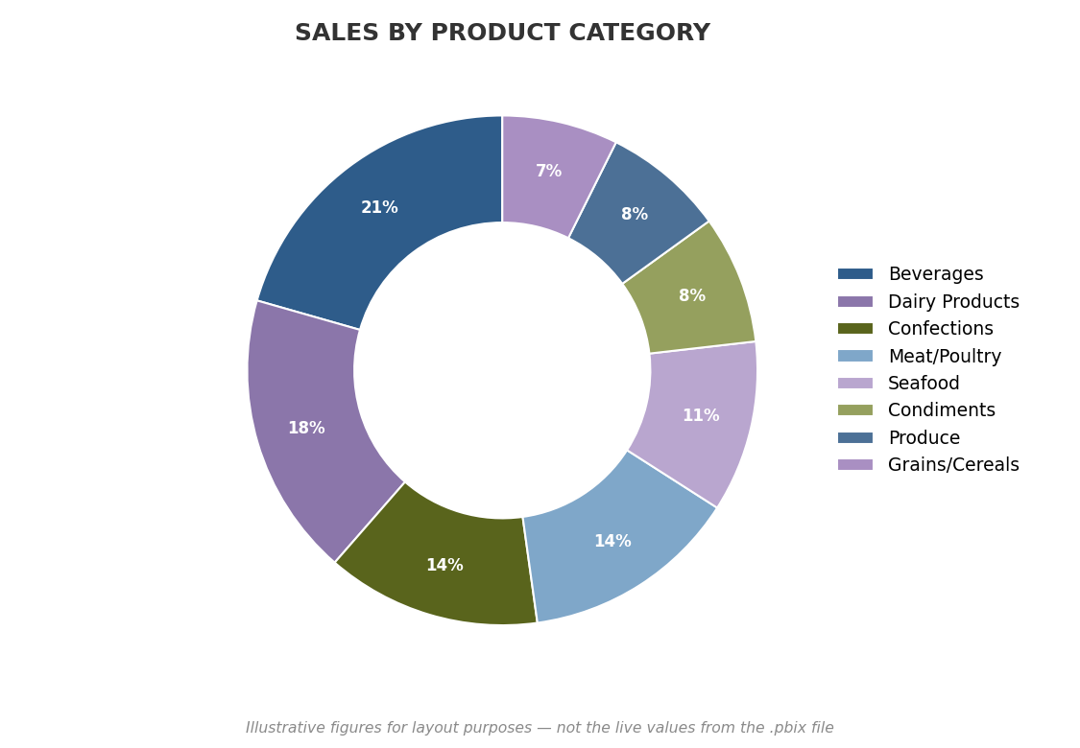
Figure 6. Sales by Product Category (share of total).

Product Detail Table
A dedicated table page lists Product Name alongside Total Sales, Total Order, Total Quantity Sold, and Total Freight, giving a row-level view for anyone who wants the underlying numbers rather than a chart.

Category Drill-Through Page
A drill-through page lets a user right-click a category (for example, Dairy Products) on the main dashboard and jump to a focused page showing Total Sales and Total Quantity Sold for that category alone, with a Back button to return to the main view.

Sales Tooltip Page
A custom tooltip page shows Total Sales, Total Quantity Sold, and Total Order in a compact card layout, configured to appear when hovering over data points elsewhere in the report.

7. Slicers Used
To make the dashboard interactive rather than a fixed report, I added three slicers:
- Year
- Country
- Category Name
These let a user narrow the entire dashboard down to a specific year, a single country, or a single product category, and every visual updates together — the same interactive pattern used in the Walmart dashboard's Year, Store, and Holiday Status slicers.

8. Key Findings
A few things stood out from how the model and visuals came together:
- Sales and order volume are spread unevenly across product categories, which the column and donut charts surface clearly.
- Order volume over time (the monthly trend line) is the fastest way to spot growth, dips, or seasonality in the business.
- Breaking orders down by employee highlights which members of the sales team are handling the largest share of business.
- The customer base is not evenly distributed by country, which the Customers by Country chart makes immediately visible.
- Linking the report to a relational model (rather than one flat table) meant the relationships between orders, products, and customers had to be right before any visual would filter correctly — unlike the single-table Walmart dataset, this was as much a data-modelling exercise as a dashboarding one.
Note: this report describes the dashboard's structure, measures, and visuals as built in the .pbix file. The exact figures behind each KPI (total sales value, order counts, etc.) live inside Power BI's compressed data model and aren't visible outside of opening the file in Power BI Desktop. The charts in Section 6 are illustrative mockups built to match the report's layout and chart types — not screenshots of the live numbers — open the .pbix in Power BI Desktop to capture real screenshots with the actual figures, the same way the specific dollar figures were captured from the Walmart dashboard's screenshots.

9. Conclusion
Working on this project gave me a much better feel for how Power BI handles a properly relational dataset rather than a single spreadsheet. Getting the relationships between orders, order_details, products, customers, and employees right mattered more than any individual chart choice — once the model was correct, the KPI cards, trend line, and category breakdowns all followed naturally from the same six measures.
Adding the drill-through page and a custom tooltip page pushed the report a step further than a flat set of charts, since it let a user move from a category-level overview straight into that category's detail without leaving the flow of the report. Overall, this project helped me understand not just Power BI as a tool, but how a well-modelled dashboard can make a relational dataset like Northwind genuinely easy to explore.

10. References
- Microsoft Power BI Desktop
- Northwind Traders Sample Database
- Microsoft Power BI Documentation

